Programming with Python & Problem Solving (05MC0107)

Lab Manual (2026-27)

Program: MCA Semester: 1
Name of the Student: SAMIR SAJIDBHAI SUMRA Enrolment No.: 92600584103

INDEX

Lab | Program | Date | Remarks | Signature
1 | Write a program to demonstrate basic input and output operations in Python. | 17/08/2026
2 | Write a program to illustrate the use of different data types and type casting. | 17/08/2026
3 | Write a program to perform arithmetic relational and logical operations using Python operators. | 17/08/2026
4 | Write a program to demonstrate string  operations including slicing formatting and built-in string functions. | 17/08/2026
5 | Write a program to create and manipulate lists using indexing slicing and list comprehensions. | 17/08/2026
6 | Write a program to illustrate the use of tuples and sets with basic operations. | 17/08/2026
7 | Write a program to create a dictionary and  demonstrate dictionary methods and iteration. | 17/08/2026
8 | Write a program to explain mutable and immutable objects in Python. | 17/08/2026
9 | Write a program to define and use user-defined functions with different types of arguments. | 17/08/2026
10 | Write a program to demonstrate recursion using factorial or Fibonacci series. | 17/08/2026
11 | Write a program to demonstrate conditional statements using if if-else and if-elif-else. | 30/08/2026
12 | Write a program to check whether a number is positive negative or zero using nested conditions. | 30/08/2026
13 | Write a program to generate a multiplication table using a for loop. | 30/08/2026
14 | Write a program to find the sum of digits of a number using a while loop. | 30/08/2026
15 | Write a program to demonstrate the use of break continue and pass statements. | 30/08/2026
16 | Write a program to iterate over lists strings and dictionaries using loops. | 30/08/2026
17 | Write a program to demonstrate list dictionary and set comprehensions. | 30/08/2026
18 | Write a program to illustrate variable scope using local global and nonlocal variables. | 30/08/2026
19 | Write a program to demonstrate iterators and iterables in Python. | 30/08/2026
20 | Write a program to generate a sequence of  numbers using generator functions and yield keyword. | 30/08/2026

21
22
23
24
25
26
27
28
29
30
31
32
33
34
35
36

Practical No. 11
Definition:
Write a program to demonstrate conditional statements using if if-else and if-elif-else.

Aim / Objectives:
- To understand the concept of conditional statements in Python.
- To demonstrate the use of the if statement.
- To demonstrate the use of the if-else statement.
- To demonstrate the use of the if-elif-else statement.
- To learn how to execute different statements based on given conditions.

Source Code:
# Using if statement age = 20
if age >= 18:
print("You are eligible to vote.") # Using if-else statement
number = 10
if number % 2 == 0: print("Number is Even")
else:
print("Number is Odd")
# Using if-elif-else statement marks = 75

if marks >= 90: print("Grade: A")
elif marks >= 70: print("Grade: B")
elif marks >= 50: print("Grade: C")

else:
print("Grade: F")

Output:
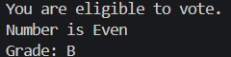

Conclusion:
Thus, the Python program successfully demonstrates the use of if, if-else, and if-elif-else conditional statements.

Practical No.12
Definition: Write a program to check whether a number is positive negative or zero using nested conditions.

Aim / Objectives:
- To understand the concept of nested conditional statements in Python.
- To write a program to check whether a number is positive, negative, or zero.
- To use if and else statements inside another conditional statement.
- To learn how to apply multiple conditions to a single problem.
- To display the appropriate result based on the entered number.

Source Code:
num = int(input("Enter a number: ")) if num >= 0:
if num == 0: print("Number is Zero")
else:
print("Number is Positive")
else:
print("Number is Negative")

Output:
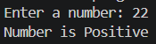

Conclusion:
Thus, the program successfully checks whether the given number is positive, negative, or zero using nested conditional statements in Python.

Practical No.13
Definition: Write a program to generate a multiplication table using a for loop.

Aim / Objectives:
- To understand the concept of for loop in Python.
- To write a program to generate a multiplication table.
- To learn how to use the range() function with a for loop.
- To perform repeated multiplication using iteration.
- To display the multiplication table in a proper format.

Source Code:
num = int(input("Enter a number: ")) for i in range(1, 11):
print(num, "x", i, "=", num * i)

Output:
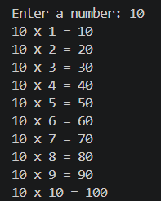

Conclusion:
Thus, the program successfully generates the multiplication table of a given number using a for loop in Python.

Practical No.14
Definition: Write a program to find the sum of digits of a number using a while loop.

Aim / Objectives:
- To understand the concept of the while loop in Python.
- To write a program to find the sum of digits of a number.
- To learn how to extract individual digits from a number.
- To perform repeated operations using a while loop.
- To display the sum of all digits of the given number.

Source Code:
num = int(input("Enter a number: ")) sum = 0
while num > 0: digit = num % 10
sum = sum + digit num = num // 10
print("Sum of digits =", sum)

Output:
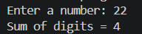

Conclusion:
Thus, the program successfully finds the sum of digits of a given number using a while loop in Python.

Practical No.15
Definition: Write a program to demonstrate the use of break continue and pass statements. Aim / Objectives:
- To understand the concept of break, continue, and pass statements in Python.
- To demonstrate the use of the break statement.
- To demonstrate the use of the continue statement.
- To demonstrate the use of the pass statement.
- To understand how these statements control the flow of a program.

Source Code:
# 1. Break statement print("Using break:") for i in range(1, 6):
if i == 4: break
print(i)

# 2. Continue statement print("\nUsing continue:") for i in range(1, 6):
if i == 3: continue
print(i)

# 3. Pass statement print("\nUsing pass:") for i in range(1, 6):
if i == 3: pass
print(i)

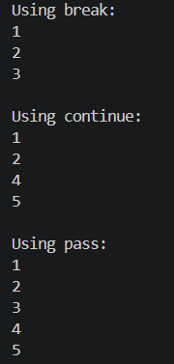
Output:

Conclusion:
Thus, the program successfully demonstrates the use of break, continue, and pass statements in Python to control the flow of execution.

Practical No.16
Definition: Write a program to iterate over lists strings and dictionaries using loops.

Aim / Objectives:
- To understand how loops are used to iterate over different data types in Python.
- To iterate over elements of a list using a for loop.
- To iterate over characters of a string using a loop.
- To iterate over keys and values of a dictionary using a loop.
- To understand the practical use of loops with Python collections.

Source Code:
# 1. Iterate over a List print("List Elements:")
fruits = ["Apple", "Banana", "Mango", "Orange"] for fruit in fruits:
print(fruit)

# 2. Iterate over a String print("\nString Characters:") name = "Python"
for ch in name: print(ch)

# 3. Iterate over a Dictionary print("\nDictionary Elements:") student = {
"Name": "Samir", "Age": 22,
"Course": "MCA"

}
for key, value in student.items(): print(key, ":", value)

Output:
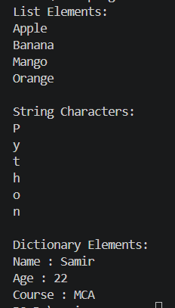

Conclusion:
Thus, the program successfully demonstrates how to iterate over lists, strings, and dictionaries using loops in Python.

Practical No.17
Definition: Write a program to demonstrate list dictionary and set comprehensions.

Aim / Objectives:
- To understand the concept of comprehensions in Python.
- To demonstrate list comprehension for creating lists.
- To demonstrate dictionary comprehension for creating dictionaries.
- To demonstrate set comprehension for creating sets.
- To learn how comprehensions make Python programs shorter and simpler.

Source Code:
# 1. List Comprehension numbers = [1, 2, 3, 4, 5]

squares = [x * x for x in numbers] print("List Comprehension:") print(squares)

# 2. Dictionary Comprehension numbers = [1, 2, 3, 4, 5]
square_dict = {x: x * x for x in numbers}

print("\nDictionary Comprehension:") print(square_dict)

# 3. Set Comprehension numbers = [1, 2, 2, 3, 3, 4, 5]
square_set = {x * x for x in numbers}

print("\nSet Comprehension:") print(square_set)

Output:
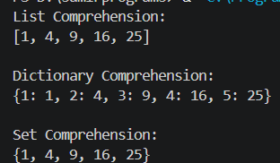

Conclusion:
Thus, the program successfully demonstrates list, dictionary, and set comprehensions in Python and shows how they can be used to create collections in a concise manner.

Practical No.18
Definition: Write a program to illustrate variable scope using local global and nonlocal variables.

Aim / Objectives:
- To understand the concept of variable scope in Python.
- To demonstrate the use of local variables.
- To demonstrate the use of global variables.
- To demonstrate the use of nonlocal variables.
- To understand how variables are accessed and modified in different scopes.

Source Code:
# Global variable x = 10
def outer():
# Nonlocal variable y = 20
def inner():
# Local variable z = 30
print("Global variable:", x) print("Nonlocal variable:", y) print("Local variable:", z)
inner() outer() Output:
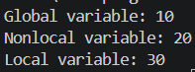

Conclusion:
Thus, the program successfully demonstrates local, global, and nonlocal variable scopes in Python.

Practical No.19
Definition: Write a program to demonstrate iterators and iterables in Python.

Aim / Objectives:
- To understand the concept of iterables and iterators in Python.
- To demonstrate how an iterable can be converted into an iterator.
- To use the iter() function to create an iterator.
- To use the next() function to access elements one by one.
- To understand the difference between an iterable and an iterator.

Source Code:
# Iterable
numbers = [10, 20, 30, 40, 50]
print("Iterable:")
for num in numbers: print(num)
# Convert iterable into iterator iterator = iter(numbers) print("\nIterator:") print(next(iterator)) print(next(iterator)) print(next(iterator)) print(next(iterator)) print(next(iterator))

Output:
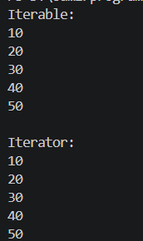

Conclusion:
Thus, the program successfully demonstrates iterables and iterators in Python using the iter() and next() functions.

Practical No.20
Definition: Write a program to generate a sequence of numbers using generator functions and yield keyword.

Aim / Objectives:
- To understand the concept of generator functions in Python.
- To learn the use of the yield keyword.
- To generate a sequence of numbers using a generator.
- To understand how generators produce values one at a time.
- To demonstrate memory-efficient sequence generation in Python.
Source Code:=
def generate_numbers(n): for i in range(1, n + 1):
yield i
# Create generator
numbers = generate_numbers(5) print("Sequence of numbers:") for num in numbers:
print(num)

Output:
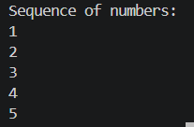

Conclusion:
Thus, the program successfully generates a sequence of numbers using a generator function and the yield keyword in Python.

